How to run BAT file
- Right Click on the file and Extract the .zip file.
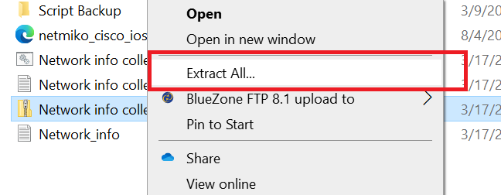
- Double click on the bat file. It should collect some logs and close automatically by creating a new file named with Network_info
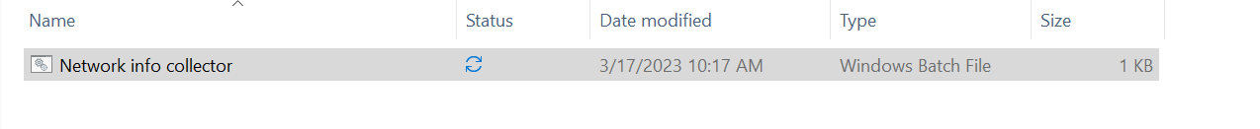
- Please share the below notepad file with us.
- In case it is shown blocked. Something like below. Then you need to unblock the file. Refer to step 5.
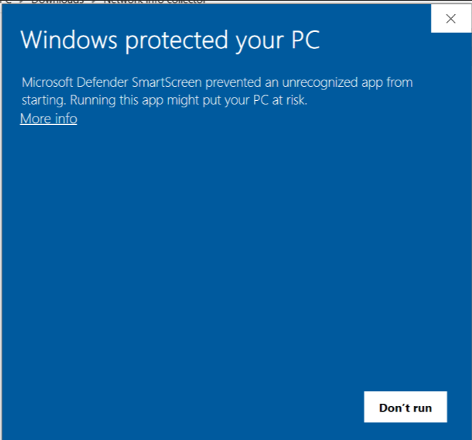
- Right click on the BAT file and go to properties.
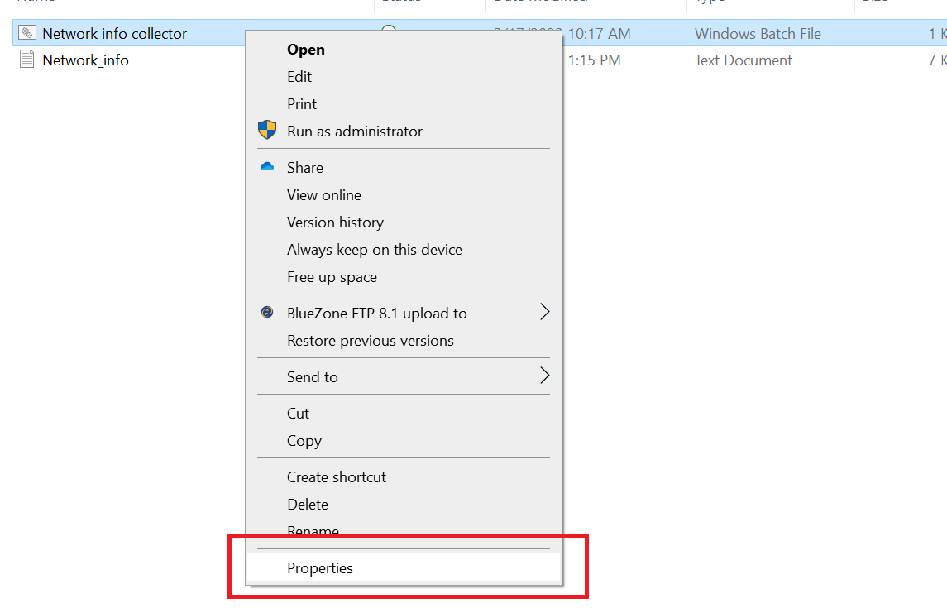
- Select unblock and then Click OK. Follow the step number 2 to run the file.
